**Experiment 4:** Design animation using GIMP.

**Step1:** In the process of a creation of simple animation in GIMP, first we need to procure images which can be made into GIF or create them using Paint.

**Step2:** Open GIMP, and go to File→Open as Layers→ And open all the pictures as layers, ordered in chronological order.

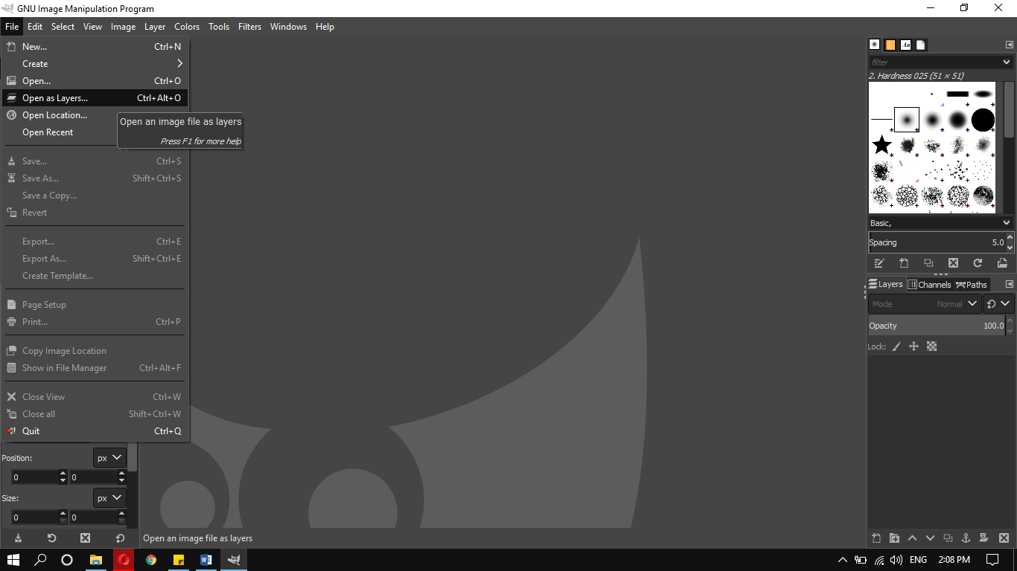

**Step3:** After opening all the pictures as layers, go to EXPORT AS and save the picture in any folder of your choice using the extension .GIF.

The Export Image as GIF dialog box pops up, export it as animation. Set the delay between frames of your choice in milliseconds, it means the time delay between the pictures.

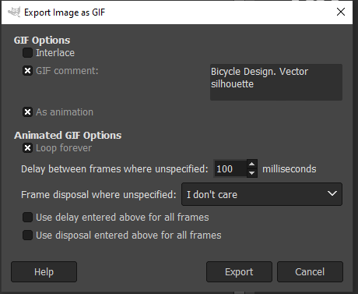

**Step4:** The saved file with the extension of .GIF is now saved and the pictures now work with the delay we set on the export dialog box.